**PRIMEMART SALES ANALYSIS**

**Important KPI’S:**

1. Sales and profit YOY:

|  |  |  |  |  |
| --- | --- | --- | --- | --- |
| **year** | **sales** | **sales_yoy** | **profit** | **profit_yoy** |
| 2020 | 43,00,793 | - | 5,04,264.79 | - |
| 2021 | 34,05,860 | -20.81 | 4,08,512.76 | -18.99 |
| 2022 | 26,77,499 | -21.39 | 3,07,415.28 | -24.75 |
| 2023 | 22,59,511 | -15.61 | 2,48,940.81 | -19.02 |

OVER all these years, the sales and profit show a huge decline. Sales has been declined by 47.44 % from 2020 to 2023 and profit has been declined by 50.62

1. Discount :

|  |  |
| --- | --- |
| **year** | **discount** |
| 2020 | 2512.638 |
| 2021 | 1935.522 |
| 2022 | 1548.774 |
| 2023 | 1333.394 |

The discount amount has been decreasing over the years, from $2,512.64 in 2020 to $1,333.39 in 2023. This suggests a trend towards offering fewer or lower discounts.

1. Average delivery time:

On an average it takes 11 days to ship the order.

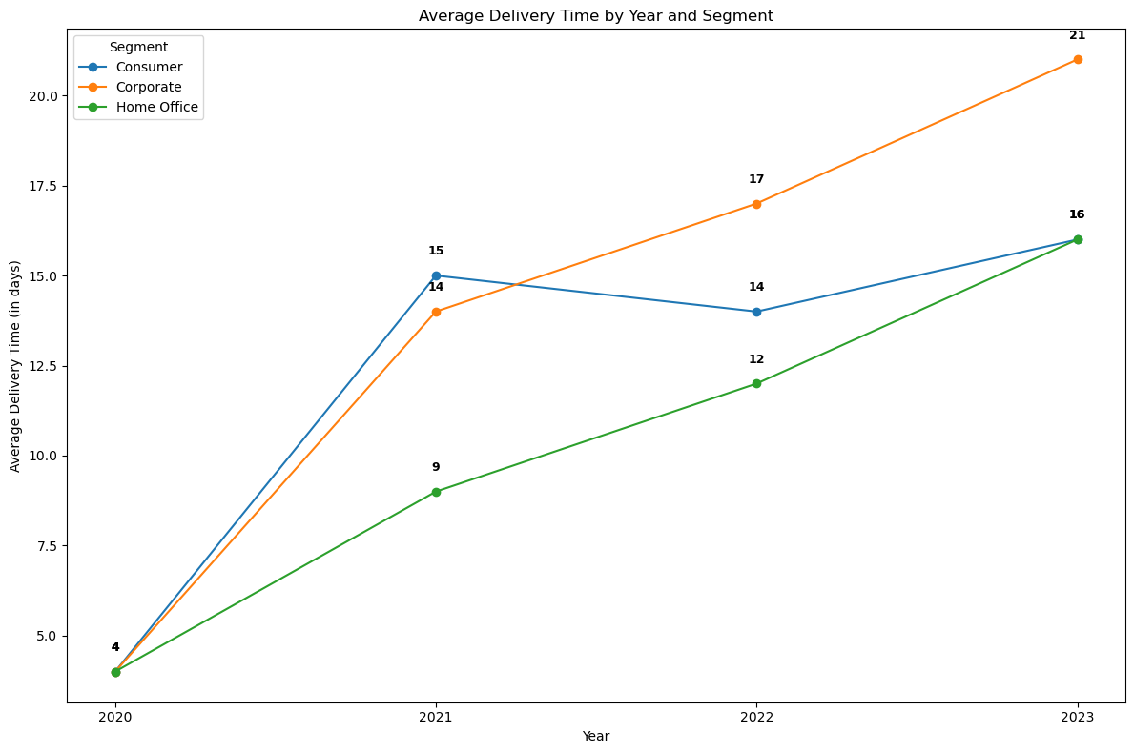

* The increase in average delivery time over time could be due to various factors, such as challenges in the supply chain, logistical issues, increased product demand, or stockouts, labour shortage. Identifying the specific cause of this increase is essential.
* Additionally, the longer delivery times and overall discount levels might be contributing factors to the decline in sales.

REAL-TIME EXAMPLE:

I recently for a kurta set on X and found one I liked. To compare, I searched for the same product on Y and, fortunately, found it there as well. The price on Y was slightly lower, and the delivery time was shorter than on X.

Naturally, as customers, we tend to choose the option that offers better pricing and faster delivery. In this instance, X lost an order due to its competitor’s more attractive pricing and delivery options. This highlights the **importance of considering competitors’ offerings when setting prices and delivery timelines.**

1. Return Percentage:

Unique orders = 25032 Total returns = 1172

Returns percentage = 4.68%

Data Findings:

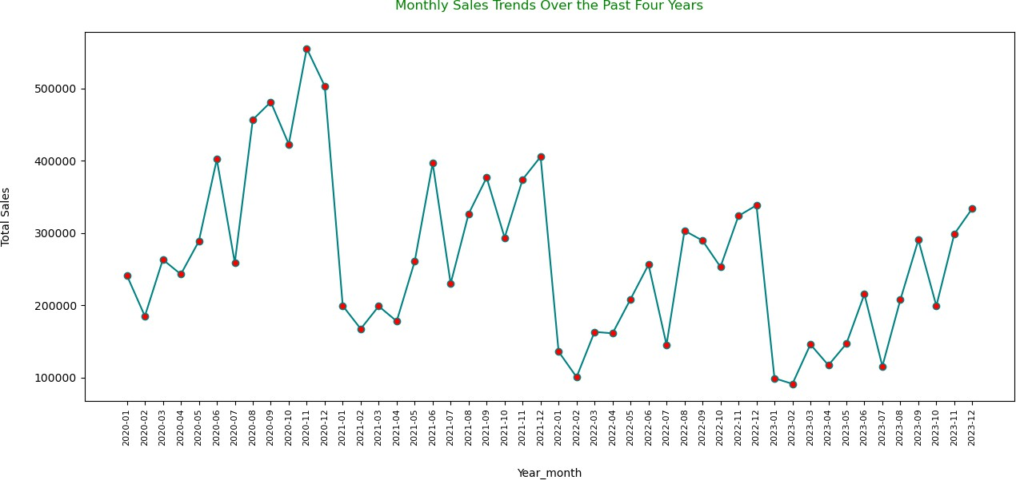Sales Trend:

The sales trend exhibits **recurring peaks and troughs occurring** at consistent intervals each year.

However, there is a notable decrease in sales during the initial two months of the year, following significant peaks observed in November and December and a significant decline in the sales trend during the month of July.

Region wise sales:

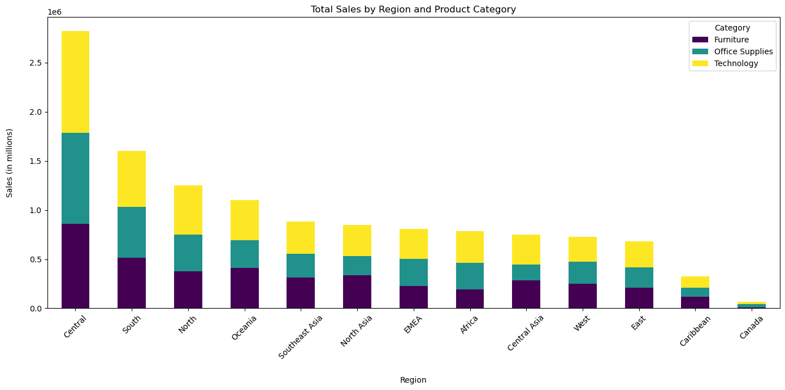

Over the years, the Central region has been the primary contributor to the company's total sales, while Canada has consistently made the smallest contribution.

In Canada, optimize inventory levelsfor tables, furnishings which have less quantity sold and labels and fasteners which have low profits to minimize excess stock.

Category wise Sales:

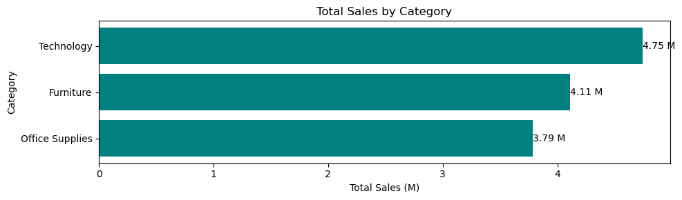

Technology Category contributes to 37.55 % of total sales, whereas furniture contributes 32.49% and office supplies contributes to 29.96%.

TOP 15 MOST PRODUCTS IN TERMS OF SALES:

|  |  |
| --- | --- |
| **product_name** | **sales** |
| Apple Smart Phone, Full Size | 86936 |
| Cisco Smart Phone, Full Size | 76441 |
| Motorola Smart Phone, Full Size | 73159 |
| Nokia Smart Phone, Full Size | 71904 |
| Canon imageCLASS 2200 Advanced Copier | 61600 |
| Hon Executive Leather Armchair, Adjustable | 58200 |
| Office Star Executive Leather Armchair, Adjust... | 50667 |
| Harbour Creations Executive Leather Armchair, ... | 50120 |
| Samsung Smart Phone, Cordless | 48654 |
| Nokia Smart Phone, with Caller ID | 47880 |
| Samsung Smart Phone, VoIP | 45406 |
| Cisco Smart Phone, with Caller ID | 43124 |
| SAFCO Executive Leather Armchair, Black | 41921 |
| Cisco Smart Phone, Cordless | 41021 |
| Novimex Executive Leather Armchair, Adjustable | 40586 |

TOP 15 MOST PROFITABLE PRODUCTS:

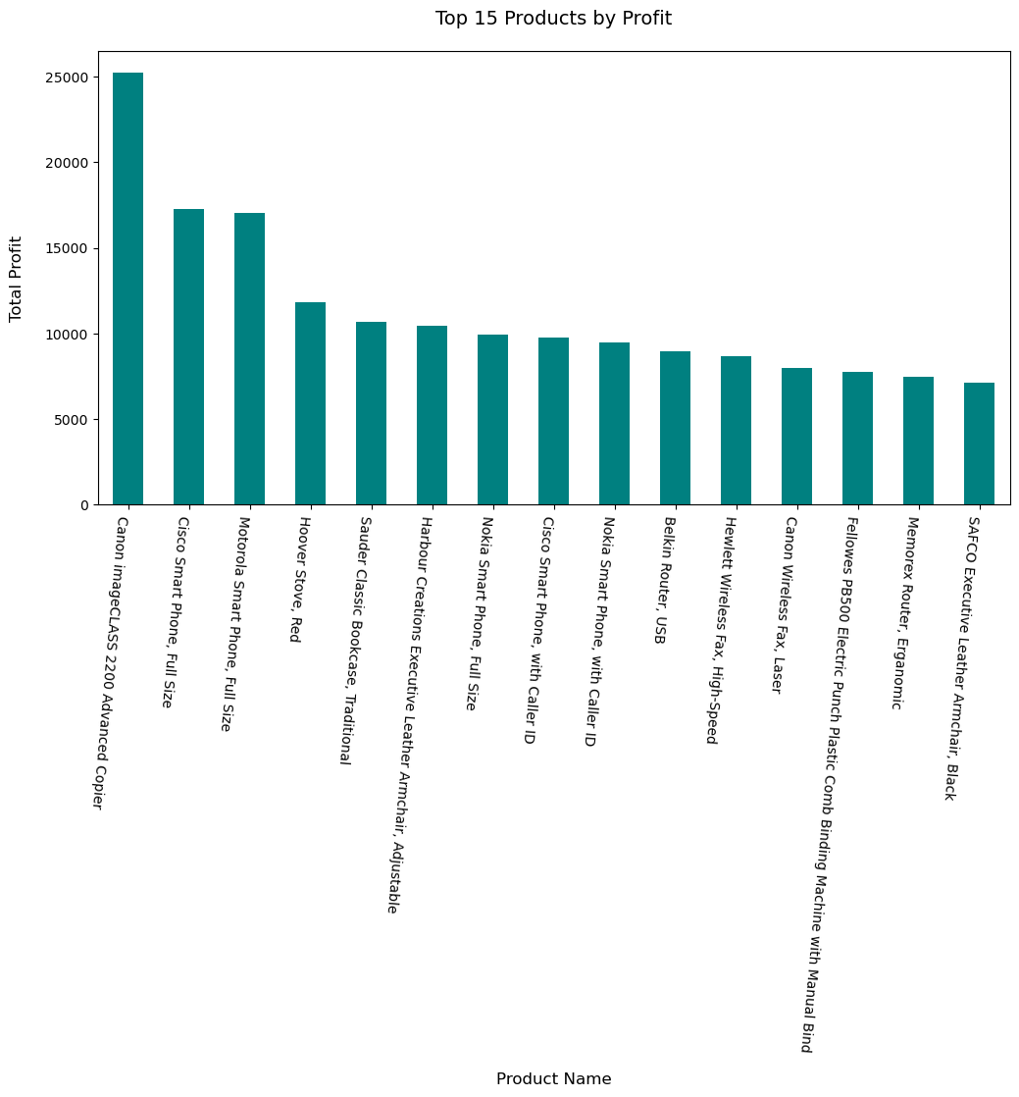

Canon Image Class 2200Advanced Copier is the most profitable product of all these years followed by Cisco Smart Phone Full Size, Motorola Smart Phone, Full Size.

## SALES VS DISCOUNT:

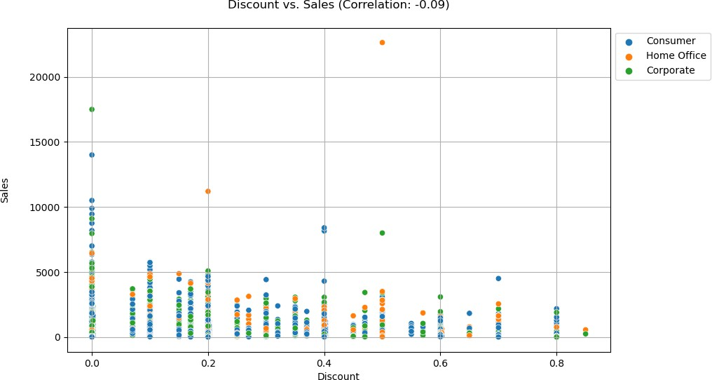

Based on the chart, there is **no significant influence of discounts on sales** for the various segment. The weak negative correlation suggests that changes in discounts do not strongly impact sales. From above, we can conclude that there is no direct influence of discount on sales.

Discount VS Profit

The correlation between discount and profit is -0.32 . It implies there is no influence of discount on profit too

PROFITABLE SEGMENT :

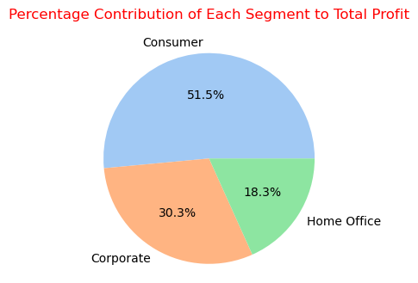

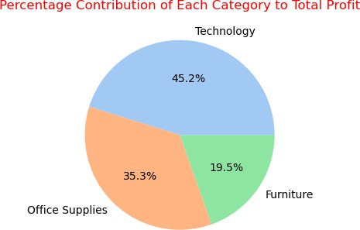

Technology category contributes almost 45%

of total profit.

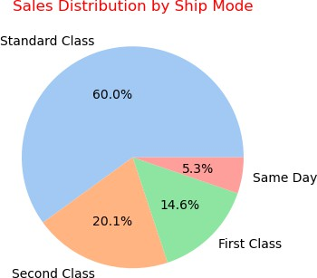

Standard Class is the dominant shipping mode, contributing approximately 60% of the total sales.

This suggests that customers prioritize affordability over speed in most cases.

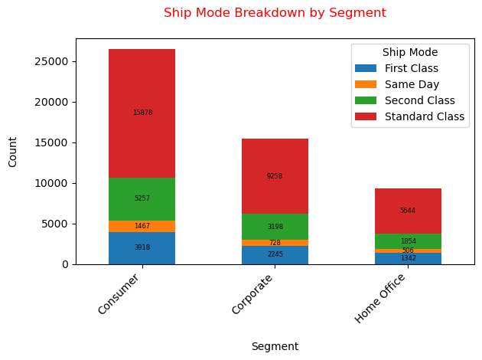

In **consumer segment, Higher proportion of Same Day compared to the other segments,** suggesting a greater willingness to pay for faster delivery.

While Standard Class dominates, there are variations in preferences between segments

FINDINGS ABOUT CUSTOMERS :

|  |  |  |  |
| --- | --- | --- | --- |
| **customer_name** | **unique_orders** | **total_orders** | **average_days_diff** |
| Frank Olsen | 47 | 85 | 37.68 |
| Anna Andreadi | 47 | 91 | 46.27 |
| Michael Paige | 47 | 94 | 37.28 |
| Kristen Hastings | 46 | 88 | 36.99 |
| Laura Armstrong | 46 | 86 | 40.31 |

Frank Olsen, Anna Andreadi, and Micheal Paige stand out as our most loyal customers, each placing 47 unique orders.

Muhammed Yedwab is one of our valued customers, having placed a total of 108 orders over the years.

Returns :

|  |  |
| --- | --- |
| segment | Total Returns |
| Consumer | 1584 |
| Corporate | 971 |
| Home Office | 500 |

The consumer segment has the highest return, which may be due to factors such as delivery time, poor product quality, or not meeting consumer expectations. Further analysis is required to determine the specific reasons, and gathering feedback on return reasons could help us improve return.

Orders have been returned only from LATAM, US, APAC, and EU markets. Orders from Africa, EMEA, and Canada markets were not returned, indicating no issues there.

**The majority of returned orders were from the LATAM and US** markets.

**INSIGHTS:**

**SALES PERFORMANCCE AND TRENDS:**

1. OVER all these years, the sales and profit show a huge decline. Sales has been **declined by 47.44 %** from 2020 to 2023 and **profit has been declined by 50.62%.**
2. Sales consistently **peaked** during the **months of November and December**, but there is a notable **drop in sales during January, February, and July**, reflecting seasonal fluctuations that affect overall revenue.

**REGION AND STATE SALES PERFORMANCE:**

1. Over the years, the **Central region has been the primary contributor to the company's total sales**, while Canada has consistently made the smallest contribution.
2. In Canada region,
   * 1. Storage, Phones, Copiers are the top selling sub- categories in terms of sales and profit.
     2. **Furnishing, Labels, Fasteners are the least 3 categories** that contribute to the overall profitability of the Canada region. Exploring strategies to boost sales or optimize costs in these categories could lead to increased overall profitability.
3. **England outperforms all other states** in both sales and profit, followed by California.

**PRODUCT CATGEORY PERFORMANCE:**

1. **Technology Category contributes to 37.55** % of total sales, whereas furniture contributes 32.49% and office supplies contributes to 29.96%.

**PROFIT PERFORMANCE:**

1. Canon Image Class 2200Advanced Copier is the most profitable product of all these years followed by Cisco Smart Phone Full Size, Motorola Smart Phone, Full Size.
2. Technology category contributes almost 45% of total profit.
3. Consumer segment contributes to 51% to the total profit.

**DISCOUNT:**

1. There is a weak correlation between discounts and sales or profits, indicating **that discounts do not have a direct impact on sales and profit.**

**DELIVERY TIME:**

1. The average time taken to ship an order is **11 days.**

**CUSTOMERS:**

1. Frank Olsen, Anna Andreadi, and Micheal Paige stand out as our most loyal customers, each placing 47 unique orders.
2. Muhammed Yedwab is one of our valued customers, having placed a total of 108 orders over the years.

**SHIPPING:**

1. **Standard Class is the dominant shipping mode**, contributing approximately 60% of the total sales. This suggests that customers prioritize affordability over speed in most cases.
2. Shipping mode by Segment:
3. In the consumer segment, a **higher proportion of customers opt for Same Day delivery** compared to other segments, indicating a greater willingness to pay for faster service.

**RETURNS:**

1. The **returns percentage stands at 4.68%**, with a total of 1172 returns out of 25,032 unique orders.
2. The **Consumer segment has the highest number of returns at 1584**, followed by corporate segment with 971 returns.
3. Orders have been returned only from LATAM, US, APAC, and EU markets. Orders from **Africa, EMEA, and Canada markets were not returned**, indicating no issues there.
4. The majority of returned orders were from the **LATAM and US** markets.

**RECOMMENDATION:**

1. **SALES OPTIMIZATION:**

* **Targeted Marketing:** Launch targeted promotions during the low sales month (Jan, Feb, July) and in low performing region to stimulate growth.

1. **PRODUCT OFFERINGS:**

* **Innovate:** Introduce new products or enhance the existing ones to meet the market trends, focusing on smart and space saving solutions. For instance, space saving furniture.
* **Expand High Performing Category:** Further focus on developing technology category to attract customers as it significantly contributes to sales and profit.
* **Re-evaluate Low performing product:** Re-evaluate underperforming sub-categories in Canada to enhance profitability
* **Optimize Pricing and Delivery:** Assess competitors’ prices and delivery timelines to ensure our offerings are competitive and meet market standards.

1. **CUSTOMER SASTIFACTION:**

* **Reduce Shipping Times**: Improve logistics and supply chain to decrease the delivery time, which will directly enhance customer satisfaction.
* **Tailor Loyalty Programs:** Develop special rewards and offers for highly valuable customers to retain a long-term relationship and encourage repeat purchases.
* **Feedback:** Collect feedback from the customers after every purchase to improve product quality by addressing issues highlighted in returns and for delivery issues or a product is not in good condition or missing items, provider faster replacement to enhance customer satisfaction.

1. **IMPROVE OPERATIONAL EFFICIENCY:**

* **Optimize costs:** Negotiate supplier contracts to secure bulk purchasing discounts and favorable terms, which will help optimize costs and improve overall cost efficiency.
* **Optimize Supply chain:** Continuously monitor supply chain to ensure optimal inventory level and reducing holding cost.
* **Address Returns**: Conduct in-depth analysis on high return markets such as LATAM, US and implement quality control measures to reduce return. This will help in reducing return cost.